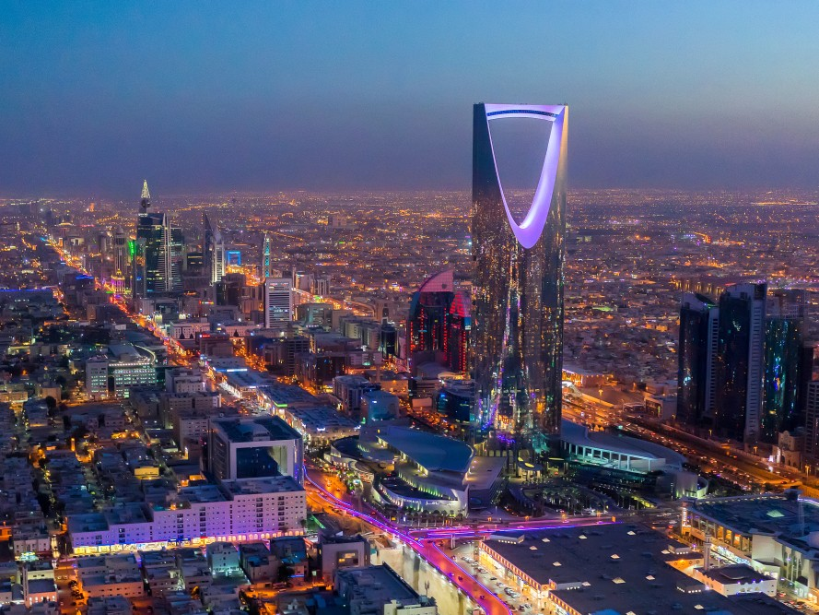
Name : Uzma Farooq
Course : M.A
Sem : 1st
Roll no : 22GGmsa122
MY DREAM DESTINATION PLACE
SAUDIA ARABIA

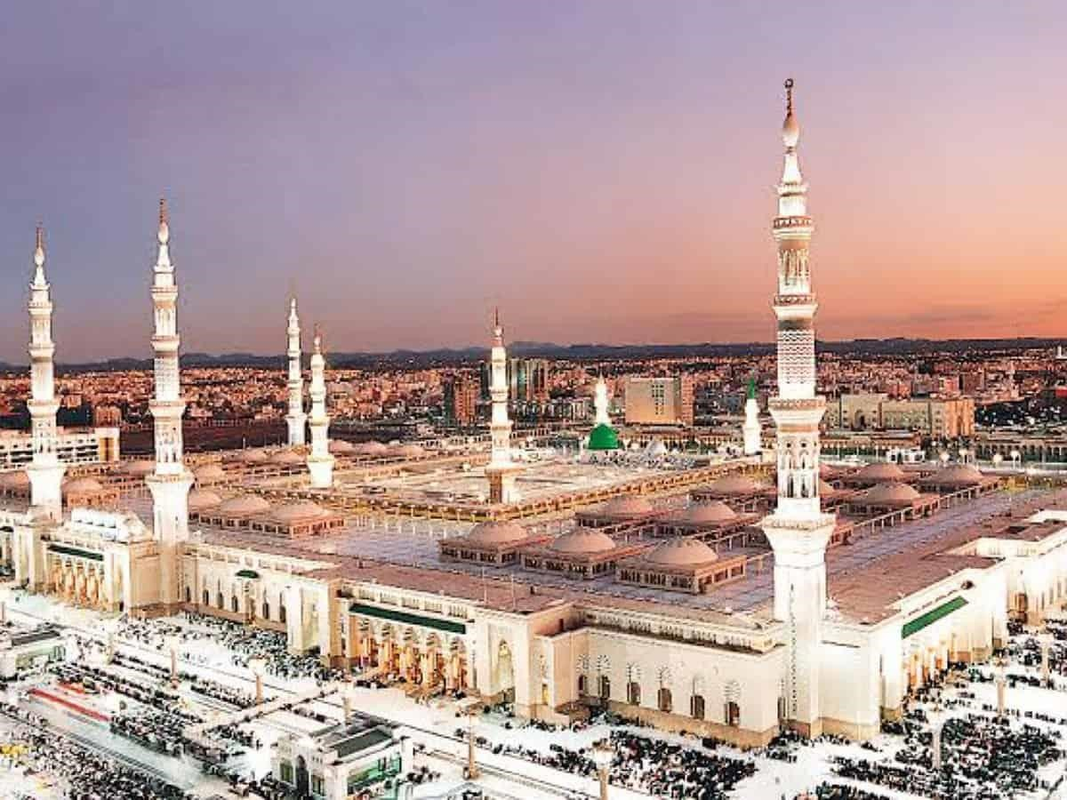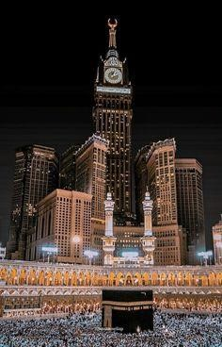

- SAUDI ARABIA IS WIDELY SEEN AS THE FINAL FRONTIER OF TOURISM. AS THE BIRTHPLACE OF ISLAM, AND A MILLENNIA-OLD CROSSROADS OF
PILGRIMS AND TRADERS, THE KINGDOM’S RICH CULTURE AND DIVERSE
HERITAGE. THE LAUNCH OF THE KINGDOM’S TOURISM VISA SAW
VISITORS FROM AROUND THE GLOBE FLOCK TO EXPLORE SAUDI’S
ANCIENT HISTORY, STRIKING LANDSCAPES, AND WARM HOSPITALITY
- SAUDI ARABIA IS RICH IN HERITAGE AND HISTORY. THE COUNTRY IS HOME TO HUNDREDS OF HISTORICALLY IMPORTANT SITES, SPANNING
FROM THE RUINS OF ANCIENT TOWNS TO JEDDAH’S MAGICAL AL BALAD
AND THE SPECTACULAR BEAUTY OF ALULA, ONE OF THE OLDEST CITIES IN THE ARABIAN PENINSULA.
- PLAN TO TAKE THIS TRIP IN THE SUMMER AFTER MY POST GRADUATION FROM UNIVERSITY. I WILL WORK FOR THE FIRST 3 MONTHS OF THE SUMMER TO SAVE
MONEY FOR THE TRIP, AND GO ONE DAY.I WILL GO ON THIS TRIP WITH ONE OF MY MOTHER OR MAY BE MY HUSBAND. THIS TRIP AND THE REASONS FOR IT ARE SOMETHING MY MOTHER AND I HAVE DISCUSSED BEFORE.
- WE WILL TAKE A FLIGHT FROM PEARSON INTERNATIONAL AIRPORT TO KING ABDUL-AZIZ AIRPORT IN JEDDAH, SAUDI ARABIA.WHEN IN SAUDI ARABIA, WE WILL RENT A CAR AND DRIVE EVERYWHERE WE NEED TO GO. AND I LOVE ROAD TRIPS! TO ADD TO THIS, GAS PRICES ARE EXTREMELY LOW IN SAUDI ARABIA, ONLY $0.16/LITRE!!PLANE.
- KING'S FOUNTAINAL-BALAD- THE "OLD CITY" OF JEDDAH.- CITY DATES BACK 2500 YEARS WHEN IT WAS INHABITED BY FISHERMEN.- I WOULD LOVE TO
WANDER AROUND THIS OLD CITY AND REVEL IN THE HISTORY.INFAMOUS SHEESHA CAFES- JEDDAH HAS A REPUTATION OF HAVING SOME OF THE BEST SHISHA CAFES, SUCH AS THE BELAJIO RESORT .
WHY SAUDI ARABIA IS MY FAVORITE DESTINATION PLACE
- WHEN THE KINGDOM OF SAUDI ARABIA OFFICIALLY OPENED ITS DOORS TO TRAVELERS FROM 49 COUNTRIES IN 2019, EARLY VISITORS UNCOVERED A VIRTUALLY UNEXPLORED
WORLD OF EXCITING CONTRASTS.RESIDENTS OF RIYADH LIVE AMONG TOWERING
SKYSCRAPERS NEXT TO STATE-OF-THE-ART FASHION MALLS ADJACENT TO ANCIENT RUINS,
YET THE CALL TO PRAYER STILL RINGS OUT LOUDLY FIVE TIMES A DAY. CHILDREN AND
YOUTH ALSO MAKE UP A SOLID TWO-THIRDS OF THE SAUDI POPULATION, WHICH MEANS
THE HISTORICALLY CONSERVATIVE KINGDOM IS LEFT GRAPPLING WITH ITS EVOLVING
IDENTITY.BUT, ONE DETAIL ABOUT THE KINGDOM OF SAUDI ARABIA HAS NOT AND WILL
NOT CHANGE. THE COUNTRY IS BRIMMING WITH WONDERS AND HISTORICAL FINDS THAT
SHOULD BE ON EVERY TRAVELER'S BUCKET LIST IF THEY'RE NOT ALREADY.IF YOU'RE AN
ADVENTURE TRAVELER, YOU'LL WANT TO KNOW ABOUT ALL THE THRILLING AND UNUSUAL
THINGS TO SEE AND EXPLORE IN THIS MYSTERIOUS KINGDOM. IF YOU'RE CONSIDERING A
VISIT TO SAUDI ARABIA IN ORDER TO SEE AND EXPLORE, READ ON TO LEARN MORE AND IT IS ALSO A HOLY BEAUTIFUL M CULTURAL PLACE I HAVE NEVER SEEN IN THIS WORLD LIKE THAT AND I M PROUD OF MYSELF BECAUSE I M A MUSLIM.

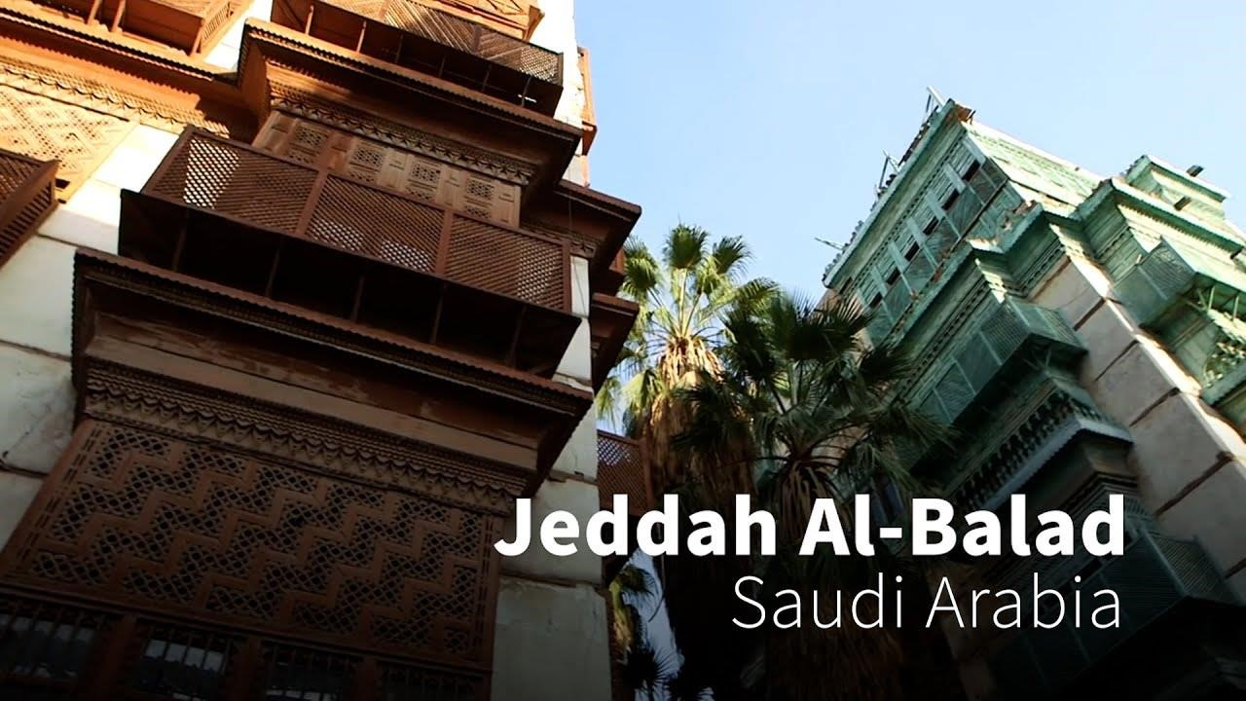

SCUBA DIVING- THIS IS A WELL KEPT SECRET OF JEDDAH AS NOT MANY PEOPLE KNOW ABOUT JEDDAH’S SCUBA DIVING.
MAKKAH HILTON HOTELMASJID-AL-HARAMTHE "SACRED MOSQUE" IS THE
HOLIEST MOSQUE IN ISLAM, AND THE PLACE OF THE UMRAH AND HAJJ
PILGRIMAGE FOR MUSLIMS.THE GRANDEUR OF THE MOSQUE IS INEXPLICABLE.IT WILL BE ANOTHER FEELING TO STAND IN FRONT OF SUCH MAJESTIC DOORS...
WE WILL VISIT MEDINA BECAUSE...-IT WAS THE FIRST CITY OF ISLAM,AND THE PROPHET'S HOME CITY. IT HASA SPECIAL SIGNIFICANCE IN ISLAM.

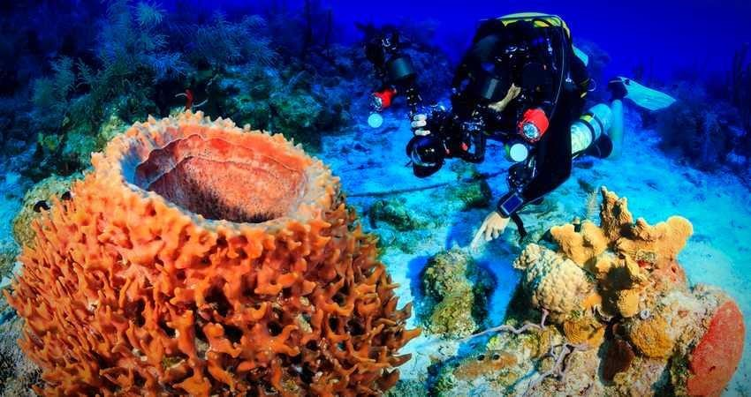
SCUBA DIVING IN JEDDAH
- WE WILL VISIT MEDINA BECAUSE...-IT WAS THE FIRST CITY OF ISLAM,AND THE PROPHET'S HOME CITY. IT HASA SPECIAL
SIGNIFICANCE IN ISLAM, ANDHENCE, IT IS A NATURAL CITY TO
VISITSINCE ONE OF THE PURPOSES OF THE TRIP IS TO LEARN MY
MORE ABOUT MYRELIGION AND ITS ROOTS.- WHILE IN MEDINA, I
WILL STAY AT THE ELF TAIBAH HOTEL, WHICH IS WALKING DISTANCE
FROM THE PROPHET'S MOSQUE.-THE RATE FOR THIS HOTEL WILL BE AROUND $150/NIGHT.
- MASJID-AL-NABAWI"THE PROPHET'S MOSQUE" WAS THE HOME OF
PROPHET IN MEDINA. IT WAS LATER CONVERTED INTO A MOSQUE.
- SHOPPING THERE ARE NUMEROUS SHOPS SELLING SOUVENIRS AS WELL AS EVERYTHING ELSE AROUND THE PROPHET'S MOSQUE.

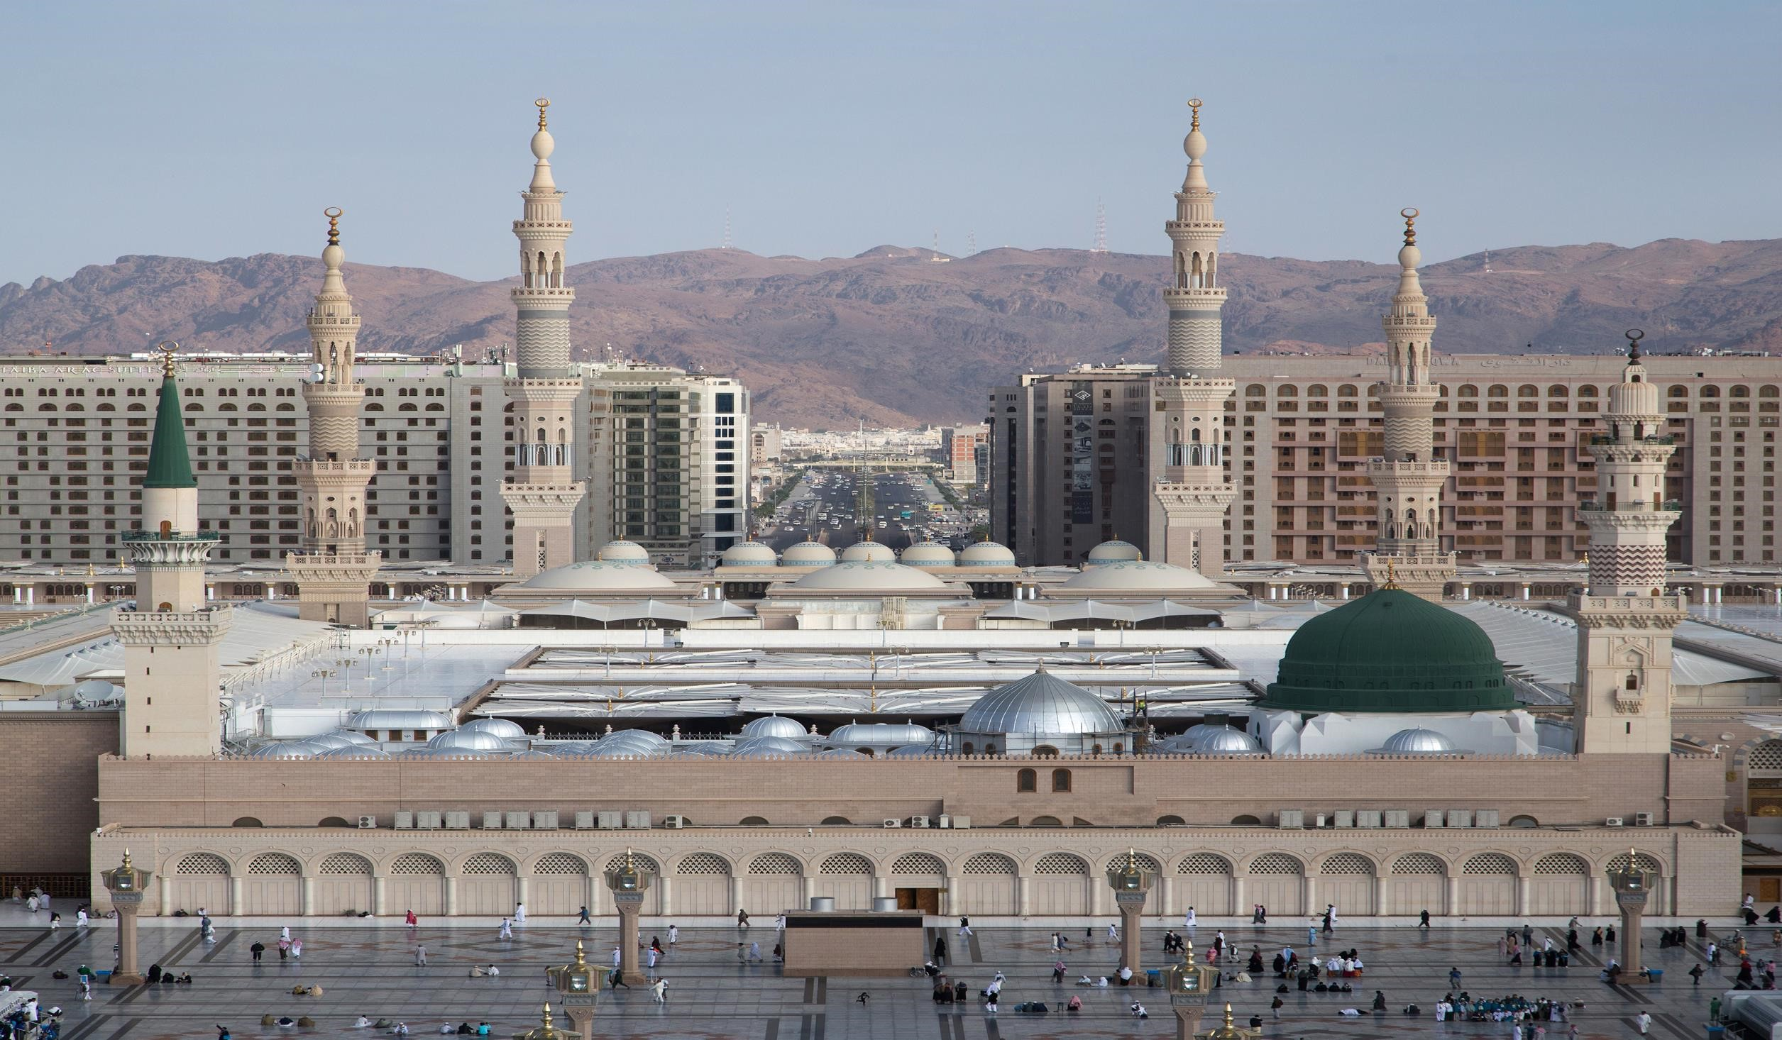
MASJID-ALNABAWI IN MEDINA
- THE MEDINA SCHEDULE...START THE DRIVE TO THE FINAL DESTINATION,
RIYADH. THIS WILL BE AN 11 HOUR DRIVE.GO SHOPPING AROUND
MEDINA AND VISIT THE PROPHET'S MOSQUE DURING THE DAYLIGHT
TO ENJOY ITS ARCHITECTURE AND BEAUTY. I THINK WE WILL NEED A WHOLE DAY TO FULLY ADMIRE THE MOSQUE.WE WILL ENJOY THE
BEAUTIFUL SCENERY ALONG THE WAY, AND TREAT THIS AS A DESERT
SAFARI. WE WILL MAKE SURE TO STOP WHEREVER WE WANT ALONG
THE WAY TO TRULY ENJOY THE TRIP WHEN IN MEDINA, I MUST TRYTHE
MOSQUE ALSO HOUSES THE PROPHET'S AS WELL AS 2 OF HIS CLOSEST
COMPANIONS' TOMBS, UNDER THE SYMBOLIC GREEN MINARET
- WHEN IN RIYADH, I MUST DO...I WOULD GO TO THE NATIONAL MUSEUM IN RIYADH AT THE VERY END OF THE TRIP.FOUR SEASONS HOTELNATIONAL MUSEUM RIYADH.
- WHEN IN JEDDAH, I MUST DO...THE KINGDOM CENTRE TOWEROVERLOOKS RIYADH, AND IS THE SECOND TALLEST BUILDING IN
SAUDI ARABIA.-THE HOTEL I WILL BE STAYING AT ALSO HAPPENS TO
BE INSIDE THIS TOWER, ALONG WITH A SHOPPING MALL. FLOATING MOSQUE A TASTE OF UNDERWATER JEDDAH- IT IS THE TALLEST
FOUNTAIN IN THE WORLD AT A HEIGHT OF 853 FEET, AND THERE ARE FREQUENT SHOWS AT NIGHT THAT I WOULD LIKE TO ENJOY.
- RIYADH SCHEDULE...PLAY GLOF AT THE DIRAB GOLF AND COUNTRY
CLUB IN THE AFTERNOON.VISIT THE NATIONAL MUSEUM AT THE END
OF THE TRIP BEFORE CATCHING FLIGHT BACK FROM THE KING
KHALID RIYADH AIRPORT TO PEARSON INTERNATIONAL AIRPORT.
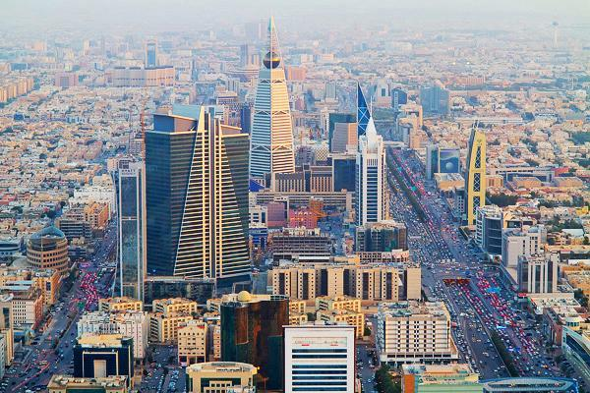
- WHEN IN MECCA, I MUST SEE...- SINCE THE GREAT MOSQUE GATHERS
MUSLIMS FROM ALL OVER THE WORLD, FROM VERY DIFFERNT CUISINES,
THE AREA AROUND THE MOSQUE THE MECCA SCHEDULE...- AFTER
REACHING MECCA FROM JEDDAH, WE WOULD GO TO THE HOTEL AND
FRESHEN UP. MOUNT NOOR- ONCE ON TOP OF THE MOUNTAIN, I WOULD
RELISH THE OPPORTUNITY TO STEP INTO THE CAVE FOR A COUPLE OF
MINUTES.- THE MOUNTAIN WITH CAVE HIRA, WHERE THE PROPHET MUHAMMAD RECEIVED HIS FIRST REVELATIONS FROM GOD THROUGH THE ANGEL GABRIEL.
- MECCA :THE MORNING AND AFTERNOON, WE WILL HIKE UP MOUNT NOOR TO CAVE HIRA.
- AND NEXT DAY WE WILL BACK TO OUR COUNTRY INDIA…WITH LOTS OF MEMORIES OF THE TRIP .

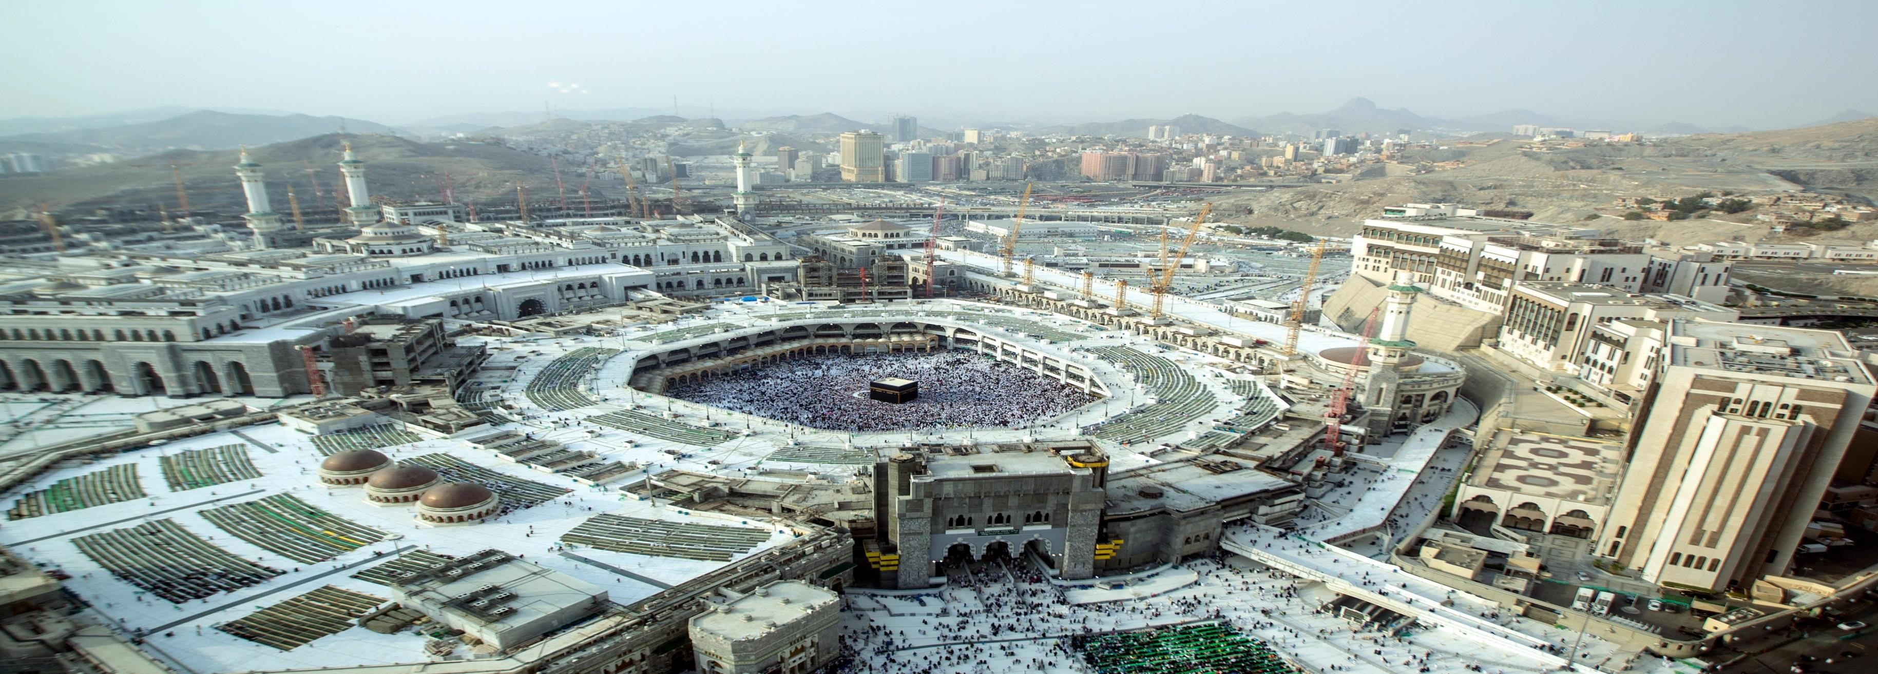
MAKKAH

